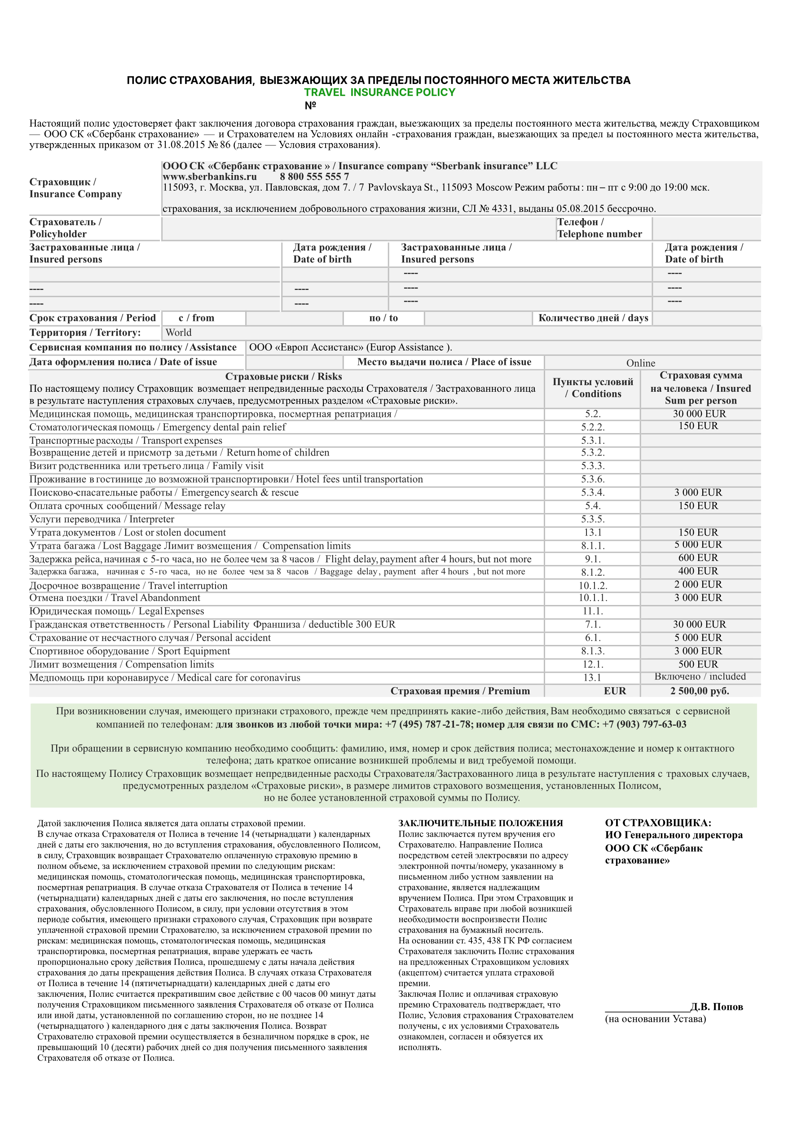

{{phone}}

{{rusName}} / {{enName}}

{{days}}

{{periodTo}}

{{periodFrom}}

{{bornDate}}

{{rusName}} / {{enName}}

**{{policN}} от {{policDate}}**

{{policDate}}

32,{{randomEUR}}